**Running Hadoop Multi-Node Cluster on Ubuntu**

We are trying to run Hadoop on 3 Virtual Machine, 1 master and 2 slave. We are creating three Virtual Machine with Unix Operating System. While configuring all the VM’s we need to go to **Settings**, select **Network**, select **Adapter 1** as “**NAT Adapter**” and **Adapter 2** as **“Host-Only Adapter”**

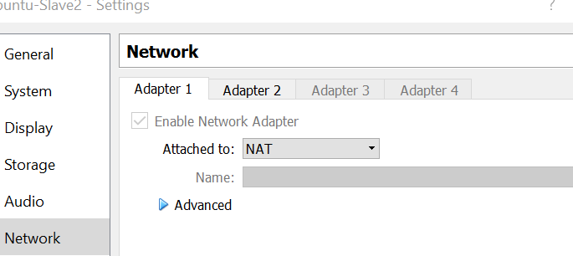

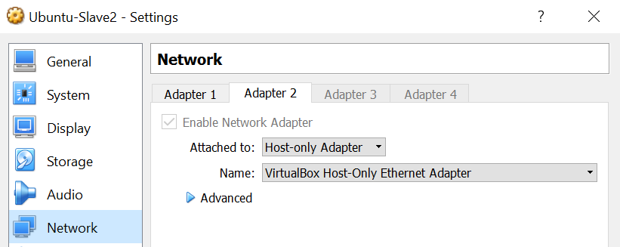

The network settings allow the VM to have communication among themselves and other one allow to have Internet access to them. For setting up multi node cluster, first we need to setup single node cluster in all the 3 VM’s. For Hadoop to run on multi node cluster the 3 VM, we need to make sure that Hadoop directory and user settings should be exactly same on all the three machines.

**Setting up Single-Node Cluster**

1. **Installing Java on the machine**

***$ sudo apt-get install python-software-properties***

***$ sudo add-apt-repository ppa:ferramroberto/java***

**$ sudo apt-get update**

**$ sudo apt-get install default-java**

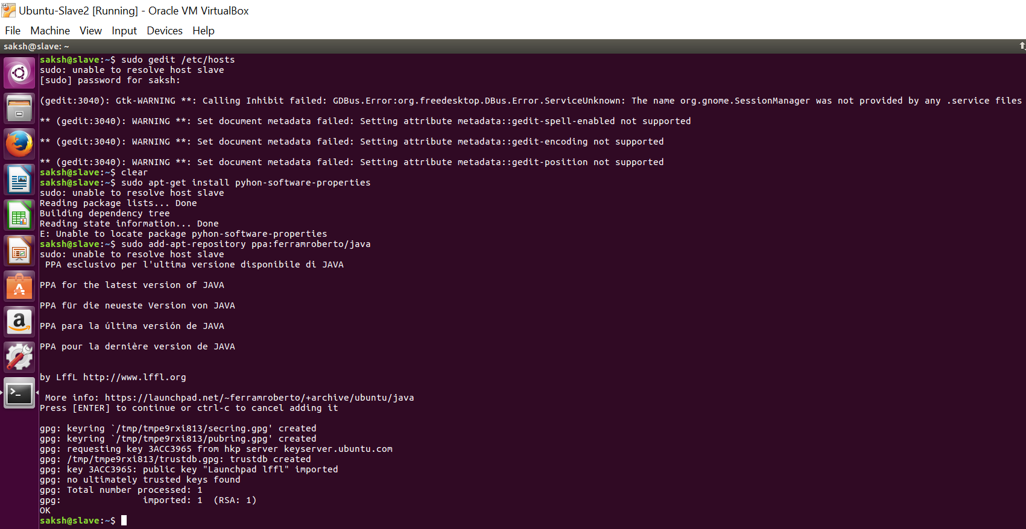

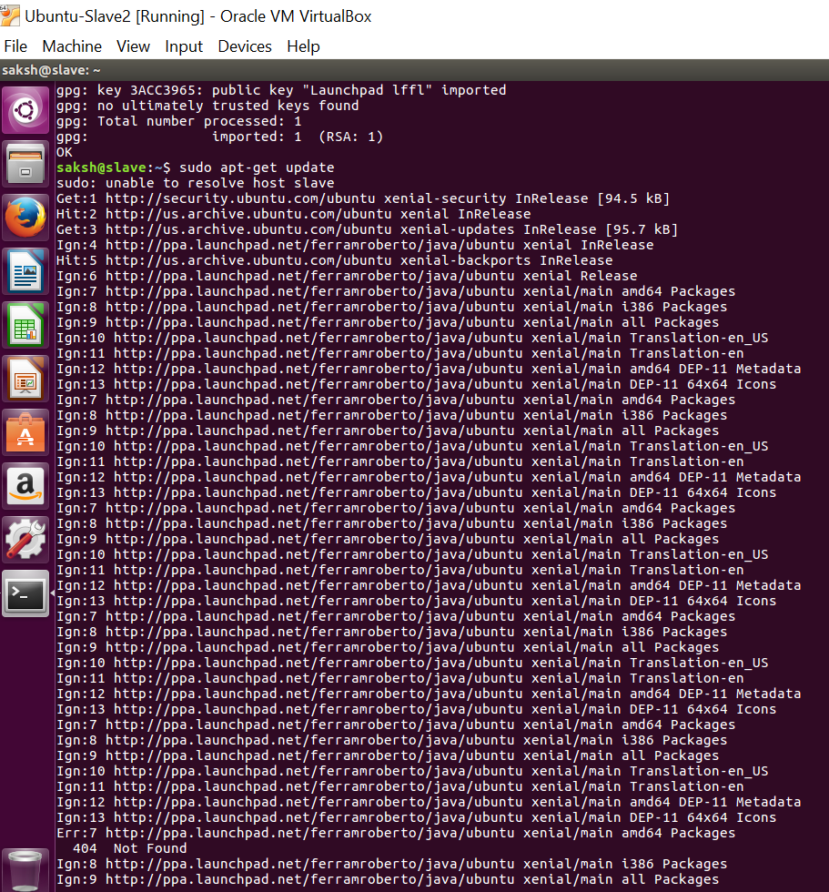

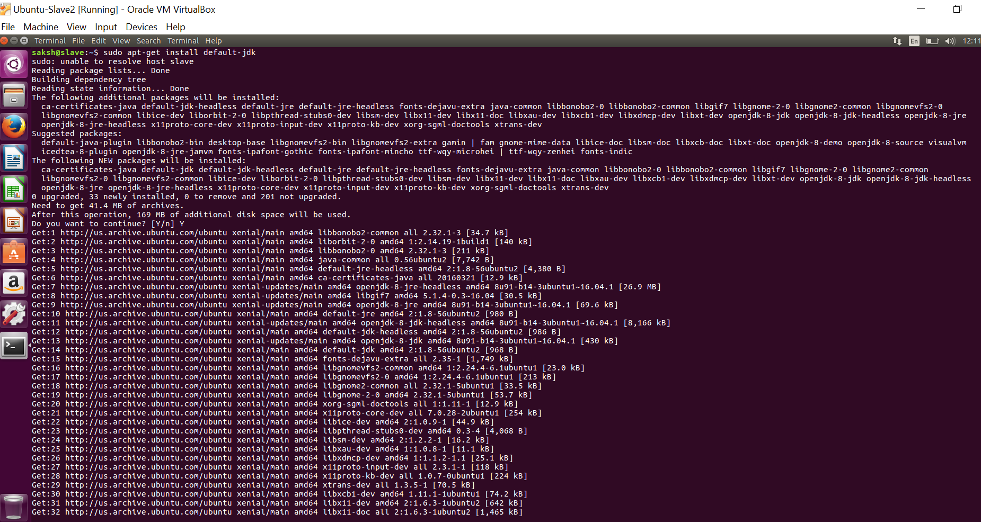

Verfiy the Java version using the command ***java -version***

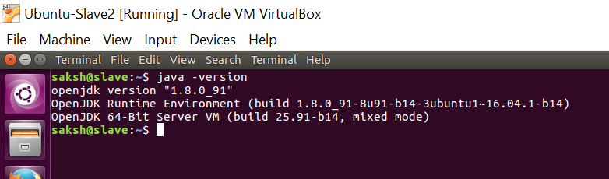

1. **Configure SSH**

First, we have to generate an SSH key for the **saksh** user.

***$ su – saksh***

***$ ssh-keygen -t rsa -P ""***

**Generating public/private rsa key pair.**

**Enter file in which to save the key (/home/saksh/.ssh/id_rsa):**

**Created directory '/home/saksh/.ssh'.**

**Your identification has been saved in /home/saksh/.ssh/id_rsa.**

**Your public key has been saved in /home/saksh/.ssh/id_rsa.pub.**

**The key fingerprint is:**

**9b:82:ea:58:b4:e0:35:d7:ff:19:66:a6:ef:ae:0e:d2 saksh@slave**

**The key's randomart image is:**

***[…snippet..]***

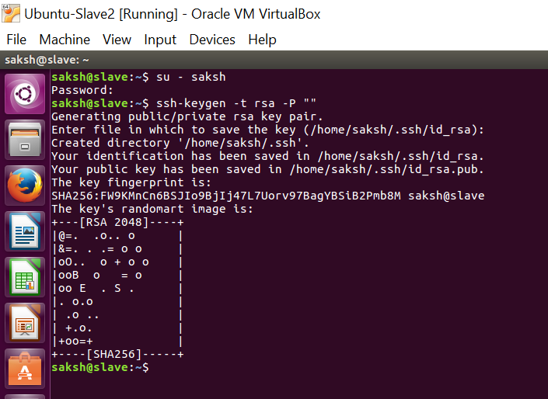

The second line will create an RSA key pair with an empty password. Generally, using an empty password is not recommended, but in this case it is needed to unlock the key without your interaction (you don’t want to enter the passphrase every time Hadoop interacts with its nodes).

Second, you have to enable SSH access to your local machine with this newly created key.

***$ cat $HOME/.ssh/id_rsa.pub >> $HOME/.ssh/authorized_keys***

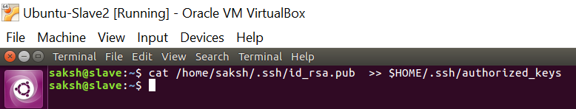

The final step is to test the SSH setup by connecting to your local machine with the saksh user. The step is also needed to save your local machine’s host key fingerprint to the saksh user’s known_hosts file. If you have any special SSH configuration for your local machine like a non-standard SSH port, you can define host-specific SSH options in $HOME/.ssh/config (see man ssh_config for more information).

***$ ssh localhost***

There might be an error, connection refused “**Connect to host localhost port 22: connection refused”**

***$ sudo apt-get install openssh-server***

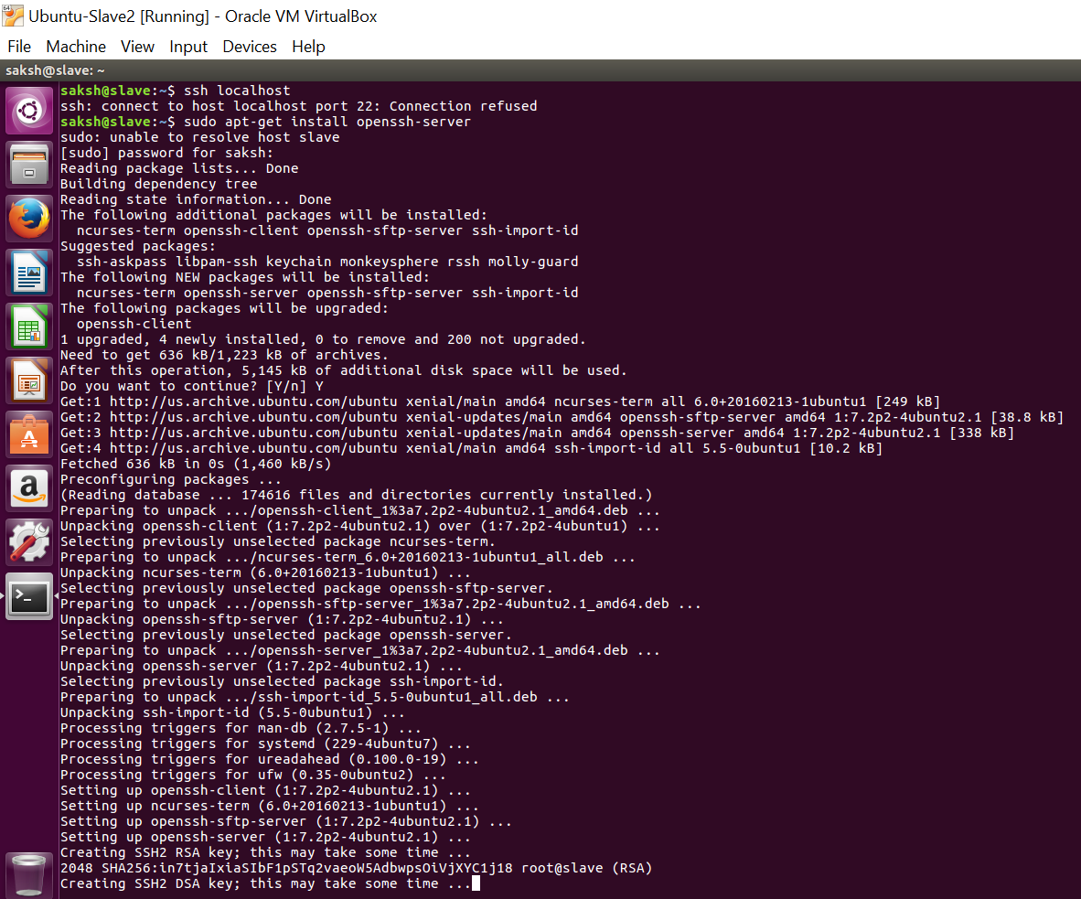

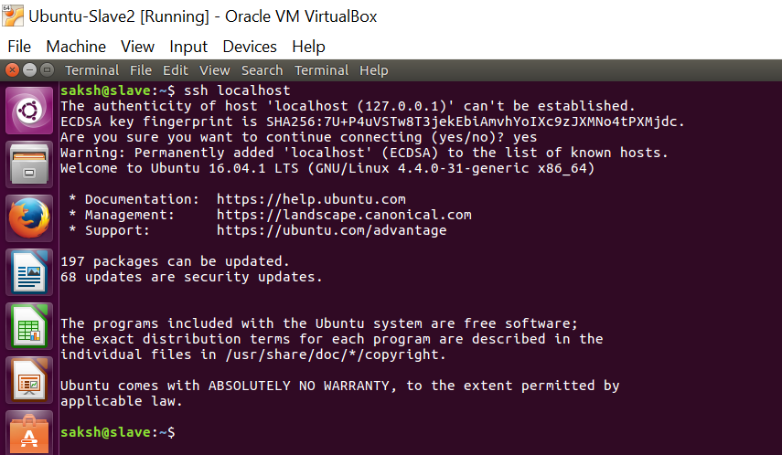

1. **Disabling IPv6**

One problem with IPv6 on Ubuntu is that using 0.0.0.0 for the various networking-related Hadoop configuration options will result in Hadoop binding to the IPv6 addresses of my Ubuntu box. In my case, I realized that there’s no practical point in enabling IPv6 on a box when you are not connected to any IPv6 network. Hence, I simply disabled IPv6 on my Ubuntu machine. Your mileage may vary.

To disable IPv6 on Ubuntu 10.04 LTS, open /etc/sysctl.conf in the editor of your choice and add the following lines to the end of the file:

***# disable ipv6***

***net.ipv6.conf.all.disable_ipv6 = 1***

***net.ipv6.conf.default.disable_ipv6 = 1***

***net.ipv6.conf.lo.disable_ipv6 = 1***

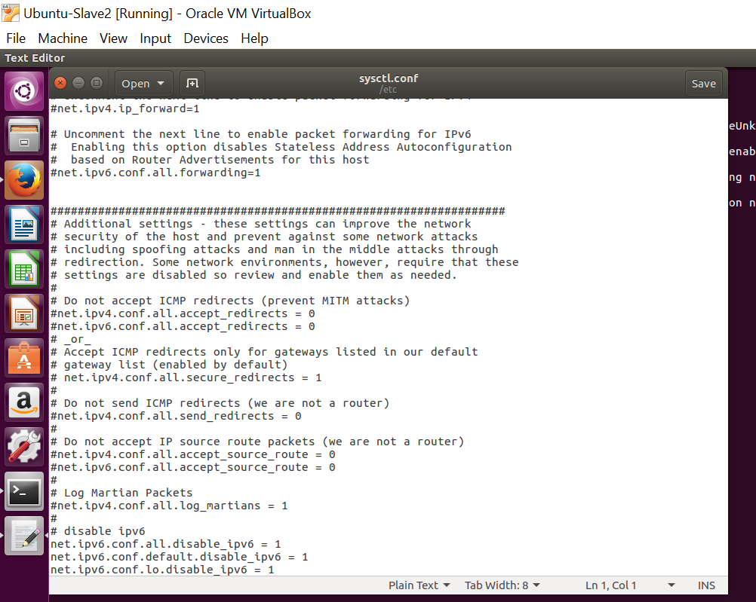

You have to reboot your machine in order to make the changes take effect. You can check whether IPv6 is enabled on your machine with the following command:

***$ cat /proc/sys/net/ipv6/conf/all/disable_ipv6***

A return value of 0 means IPv6 is enabled, a value of 1 means disabled (that’s what we want).

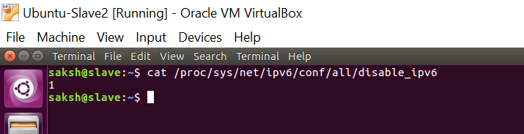

1. **Hadoop Installation**

Download Hadoop and move it to $HOME or /home/{user} directory

***$ cd /usr/local***

***$ sudo tar xzf hadoop-0.20.2.tar.gz***

***$ sudo mv hadoop-0.20.2 hadoop***

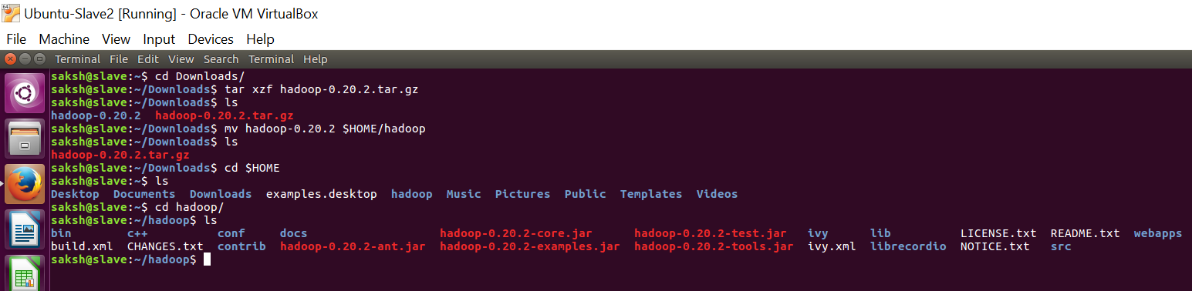

**Update $HOME/.bashrc**

Add the following lines to the end of the $HOME/.bashrc file of user saksh. If you use a shell other than bash, you should of course update its appropriate configuration files instead of .bashrc.

***# Set Hadoop-related environment variables***

***export HADOOP_HOME=/home/saksh/Hadoop***

***# Set JAVA_HOME (we will also configure JAVA_HOME directly for Hadoop later on)***

***export JAVA_HOME=/usr/lib/jvm/default-java***

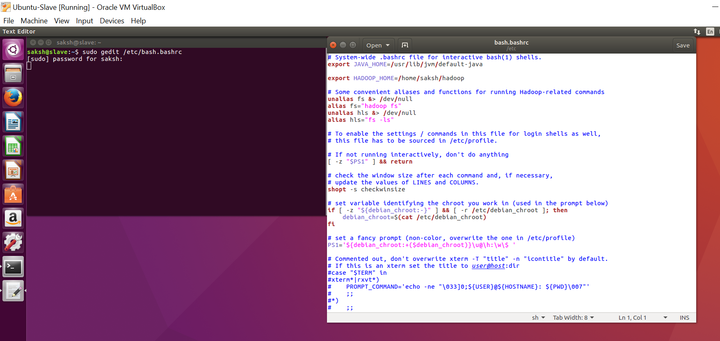

1. **Configuring Hadoop**
2. **Hadoop-env.sh**

The only required environment variable we have to configure for Hadoop in this tutorial is JAVA_HOME. Open conf/hadoop-env.sh in the editor of your choice (if you used the installation path in this tutorial, the full path is /home/saksh/hadoop/conf/hadoop-env.sh) and set the JAVA_HOME environment variable to the Java directory.

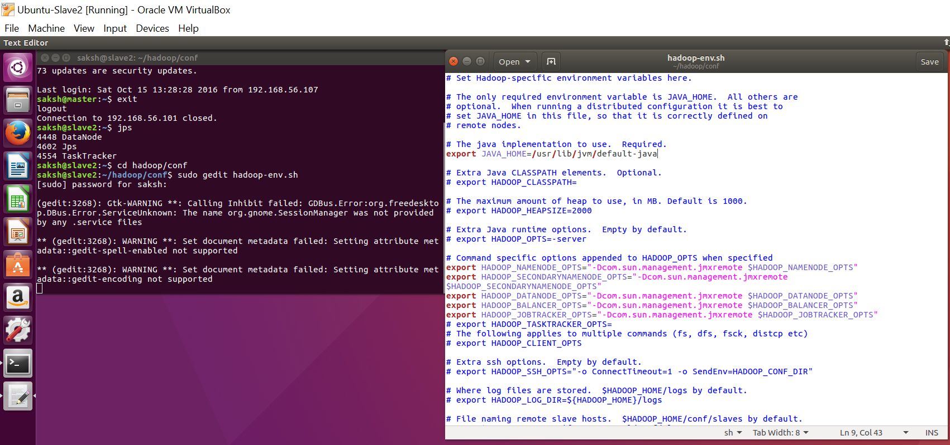

1. **conf-site.xml**

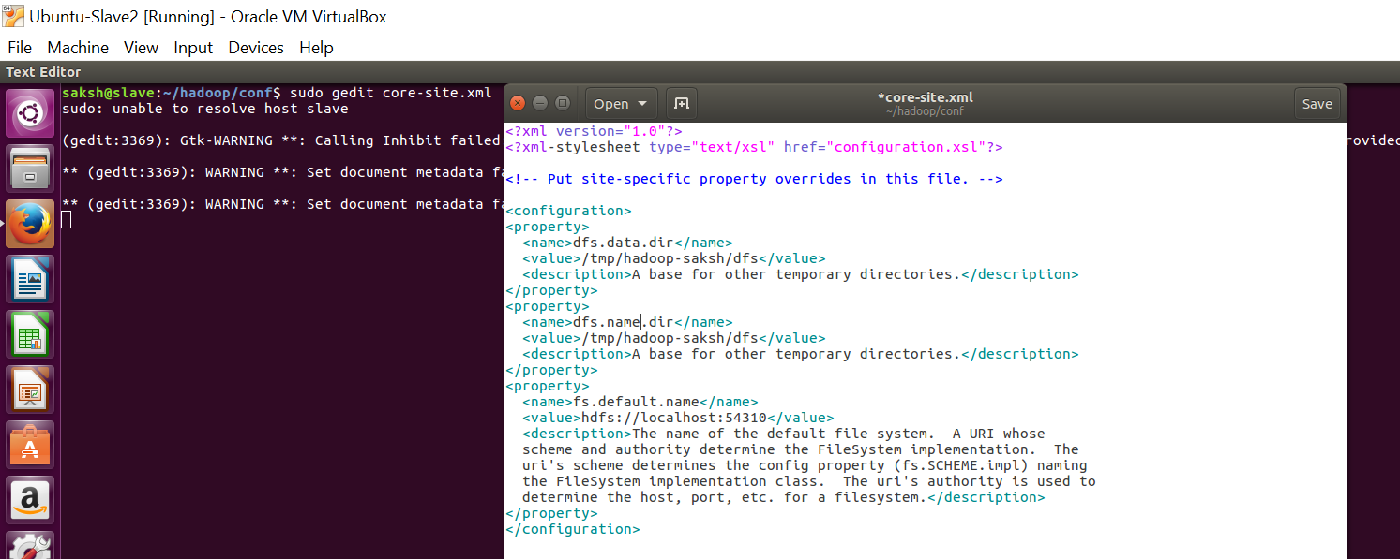

1. **hdfs-site.xml**

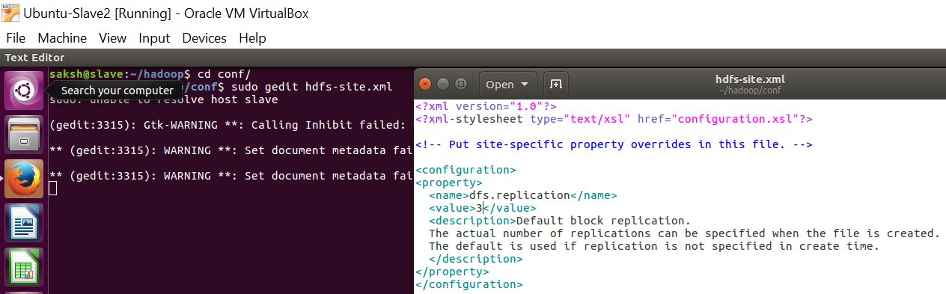

1. **mapred-site.xml**

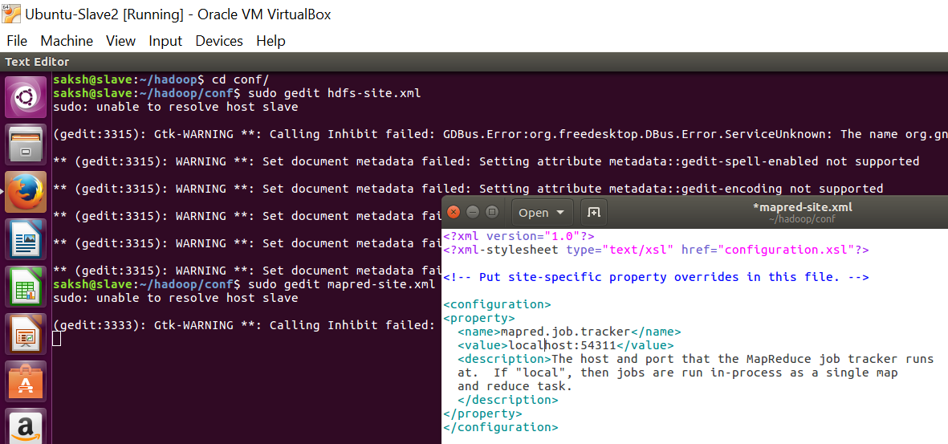

**Formatting the HDFS filesystem via the NameNode**

The first step to starting up your Hadoop installation is formatting the Hadoop filesystem which is implemented on top of the local filesystem of your “cluster” (which includes only your local machine if you followed this tutorial). You need to do this the first time you set up a Hadoop cluster.

**To format the filesystem (which simply initializes the directory specified by the dfs.name.dir variable), run the command**

**saksh@slave:~$ /home/saksh/hadoop/bin/hadoop namenode -format**

**Starting your single-node cluster**

**saksh@slave:~$ /home/saksh/hadoop/bin/start-all.sh**

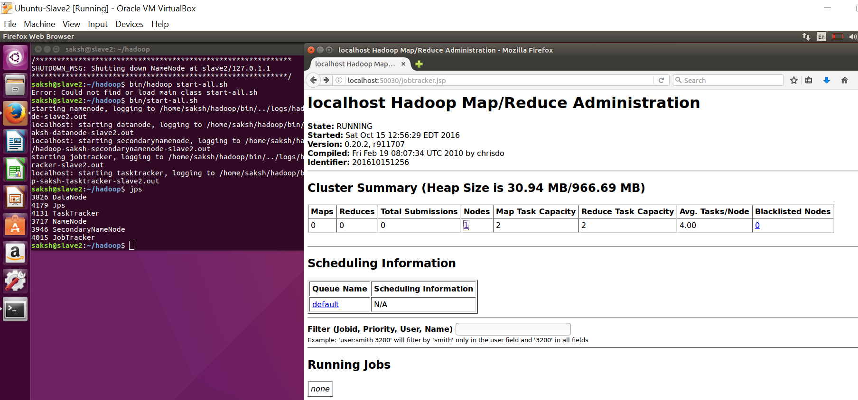

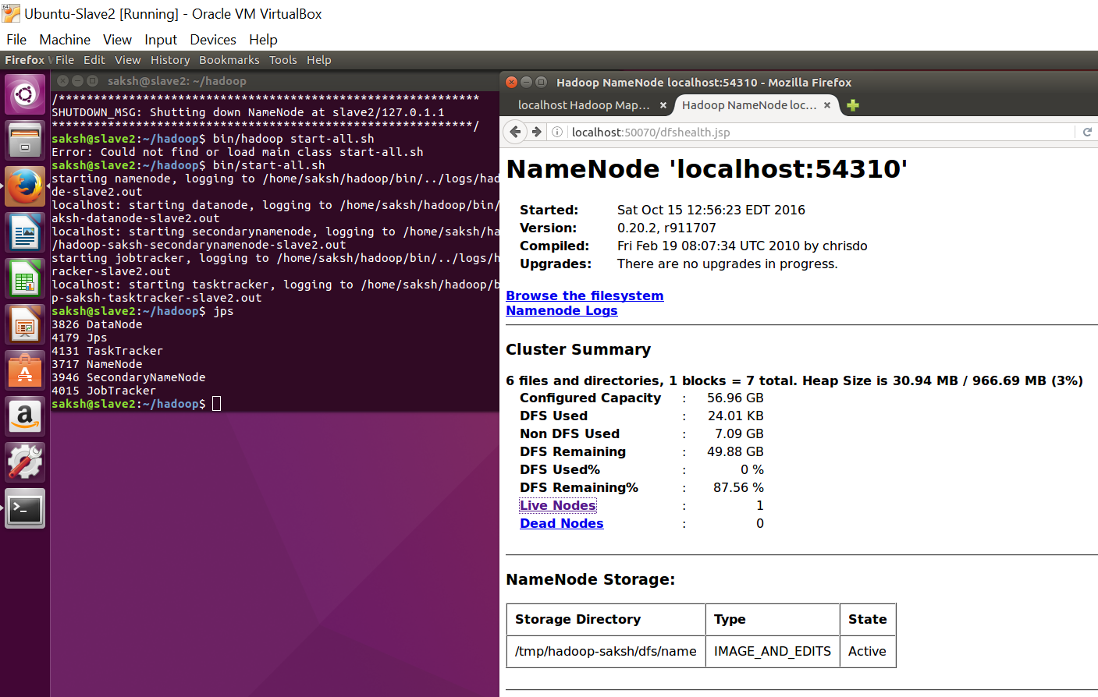

Since our Single-Node Cluster is all setup. We have performed the same set of steps on all the three Virtual Machines.

Now, we can move to setting up the Multi-Node Cluster.

**Configuring Multi-Node Cluster**

**Networking**

This should come hardly as a surprise, but for the sake of completeness I have to point out that both machines must be able to reach each other over the network. The easiest is to put both machines in the same network with regard to hardware and software configuration, for example connect both machines via a single hub or switch and configure the network interfaces to use a common network such as 192.168.0.x/24.

To make it simple, we will assign the IP address 192.168.0.1 to the master machine and 192.168.0.2 to the slave machine. **Update /etc/hosts on both machines with the following lines:**

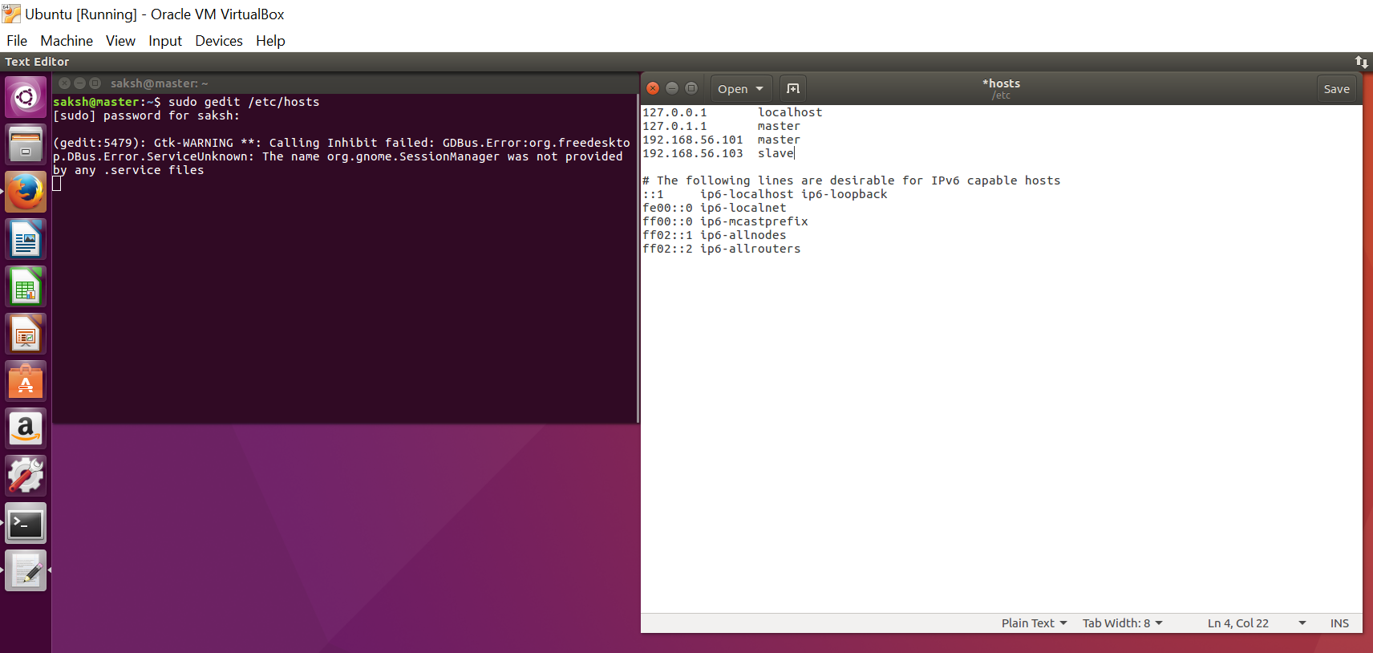

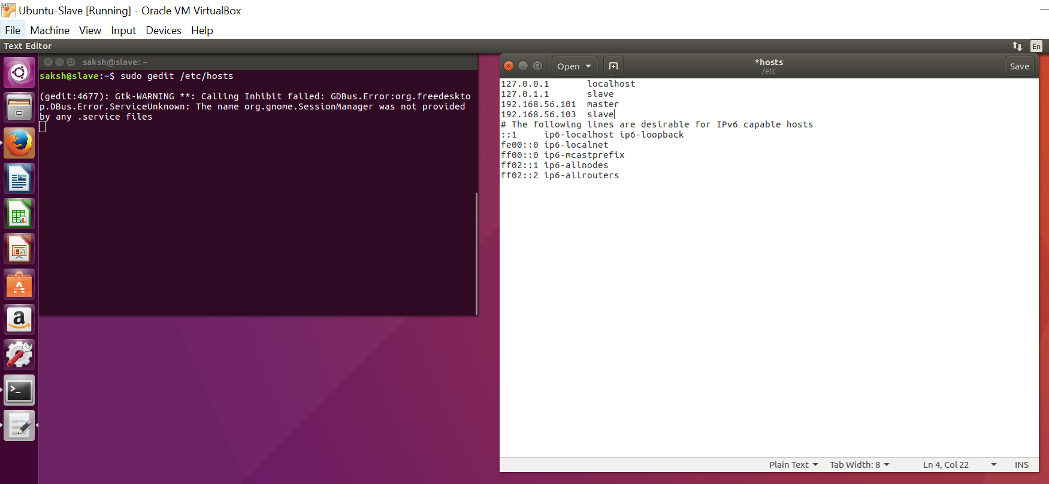

**SSH access**

The **saksh** user on the master (aka saksh@master) must be able to connect a) to its own user account on the master – i.e. ssh master in this context and not necessarily ssh localhost – and b) to the saksh user account on the slave (aka saksh@slave) via a password-less SSH login. If you followed my single-node cluster tutorial, you just have to add the saksh@master’s public SSH key (which should be in $HOME/.ssh/id_rsa.pub) to the authorized_keys file of saksh@slave (in this user’s $HOME/.ssh/authorized_keys). You can do this manually or use the

**saksh@master:~$ ssh-copy-id -i $HOME/.ssh/id_rsa.pub saksh@slave**

This command will prompt you for the login password for user saksh on slave, then copy the public SSH key for you, creating the correct directory and fixing the permissions as necessary.

The final step is to test the SSH setup by connecting with user saksh from the master to the user account saksh on the slave. The step is also needed to save slave’s host key fingerprint to the saksh@master’s known_hosts file.

So, connecting from master to master…

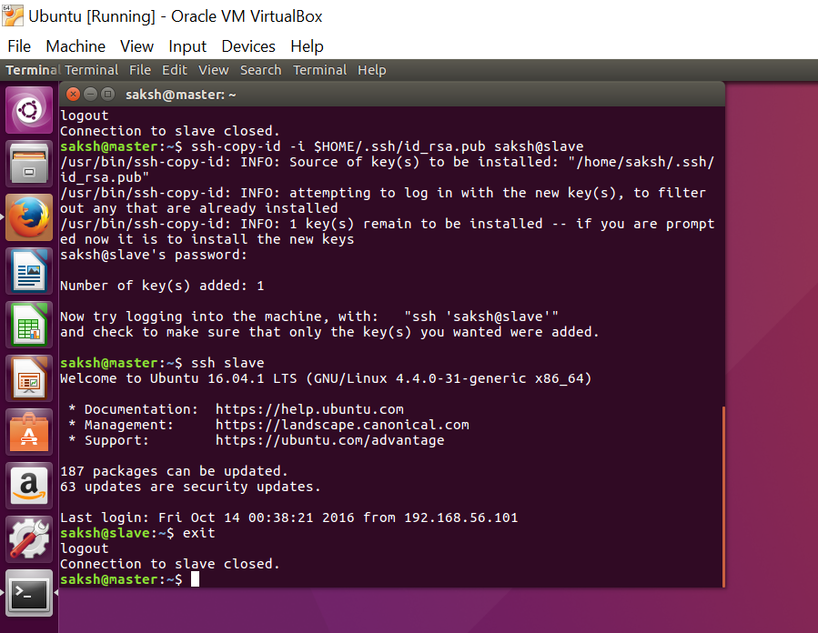

**Hadoop Configuration**

1. **conf/masters (master only)**

Despite its name, the conf/masters file defines on which machines Hadoop will start secondary NameNodes in our multi-node cluster. In our case, this is just the master machine. The primary NameNode and the JobTracker will always be the machines on which you run the bin/start-dfs.sh and bin/start-mapred.sh scripts, respectively (the primary NameNode and the JobTracker will be started on the same machine if you run bin/start-all.sh).

Again, the machine on which bin/start-dfs.sh is run will become the primary NameNode.

On master, update conf/masters that it looks like this:

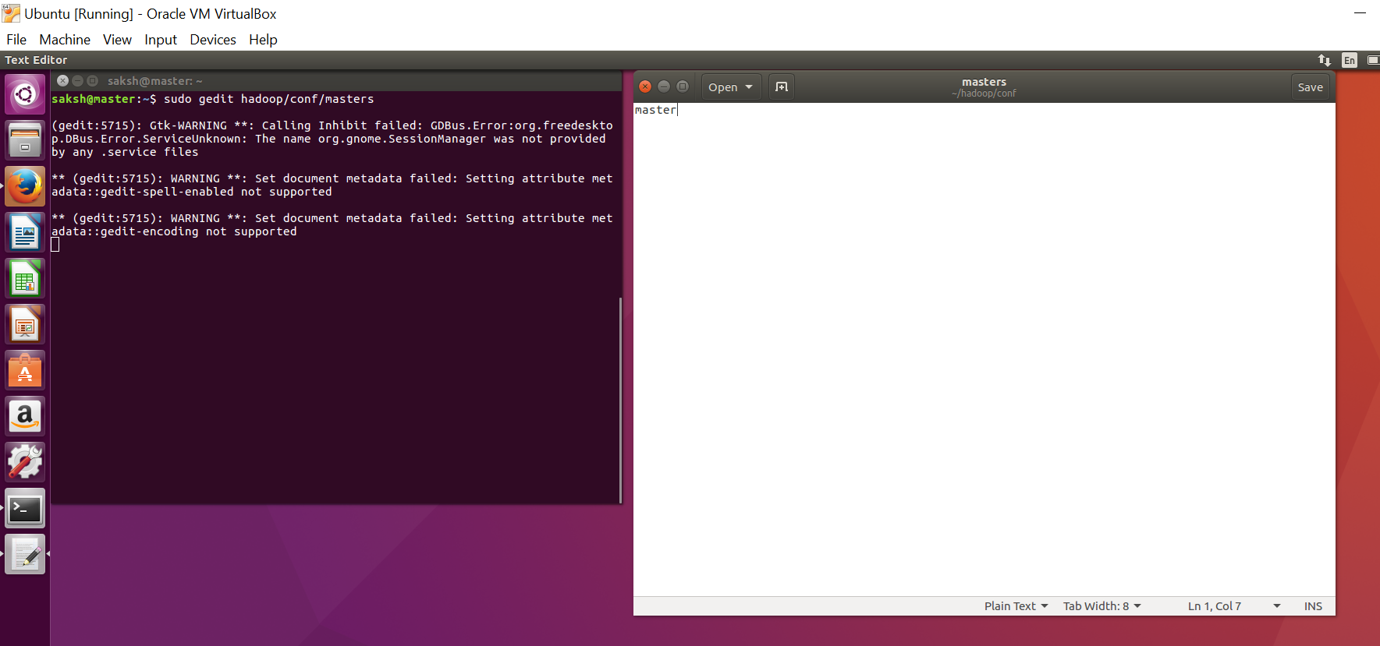

1. **conf/slaves (master only)**

The conf/slaves file lists the hosts, one per line, where the Hadoop slave daemons (DataNodes and TaskTrackers) will be run. We want both the master box and the slave box to act as Hadoop slaves because we want both of them to store and process data.

On master, update conf/slaves that it looks like this:

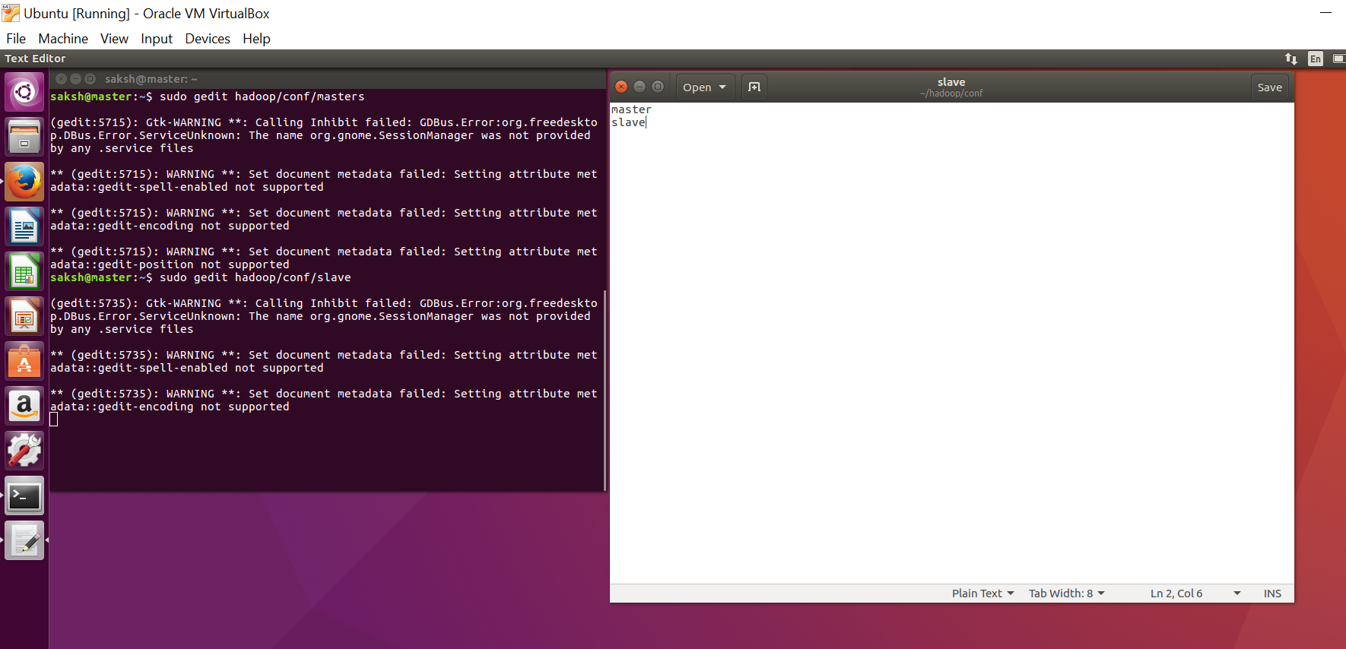

1. **conf/*-site.xml (all machines)**

You must change the configuration files conf/core-site.xml, conf/mapred-site.xml and conf/hdfs-site.xml on ALL machines as follows.

**First**, we have to change the fs.default.name parameter (in conf/core-site.xml), which specifies the NameNode (the HDFS master) host and port. The value should be **hdfs://master:54310**

**Second**, we have to change the mapred.job.tracker parameter (in conf/mapred-site.xml), which specifies the JobTracker (MapReduce master) host and port. The value will be **master:54311**

**Third**, we change the dfs.replication parameter (in conf/hdfs-site.xml) which specifies the default block replication. It defines how many machines a single file should be replicated to before it becomes available. If you set this to a value higher than the number of available slave nodes (more precisely, the number of DataNodes), you will start seeing a lot of “(Zero targets found, forbidden1.size=1)” type errors in the log files.

However, We have only three nodes available, so we set dfs.replication to 3.

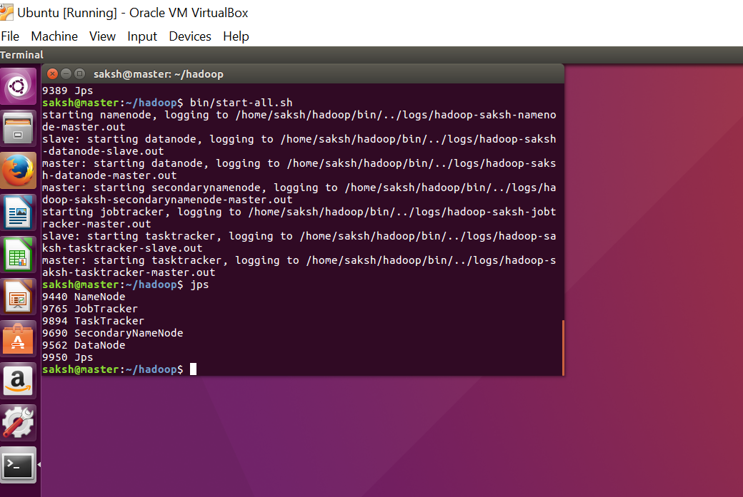

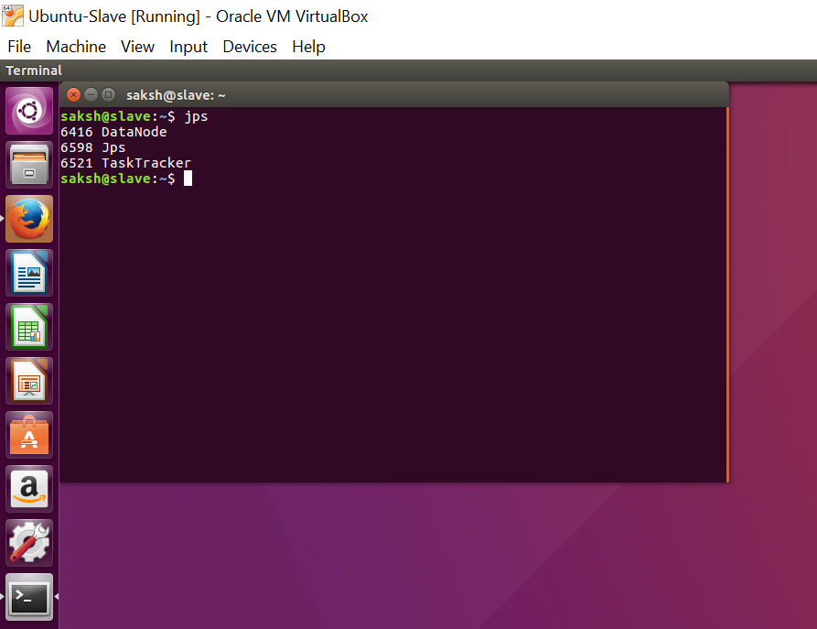

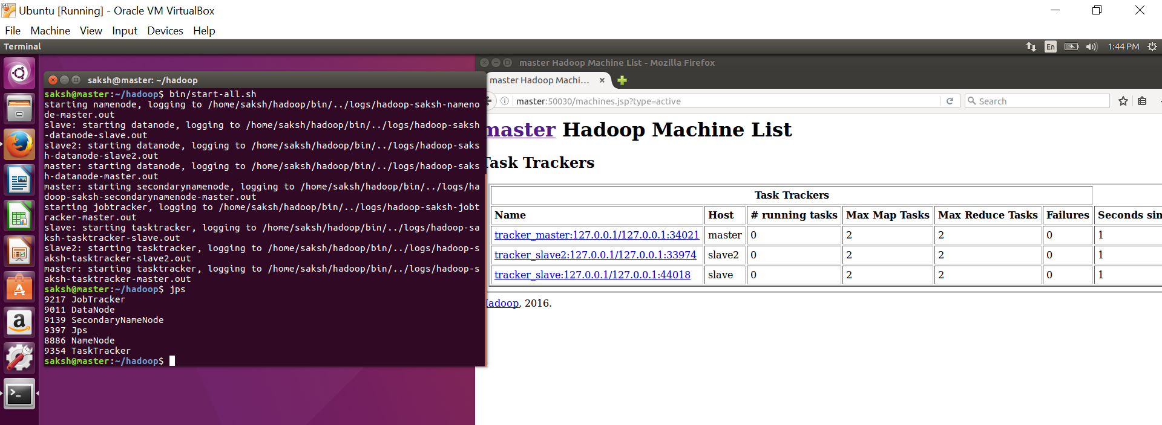

**Page Rank Algorithm**

For page rank algorithm, we start with a number of web pages, where each page points to another web page. Each web page pointing towards a another web page is considered a vote for the another web page. More the votes for a web page, the higher the rank for the web page. Google came with a formula for calculating the web page

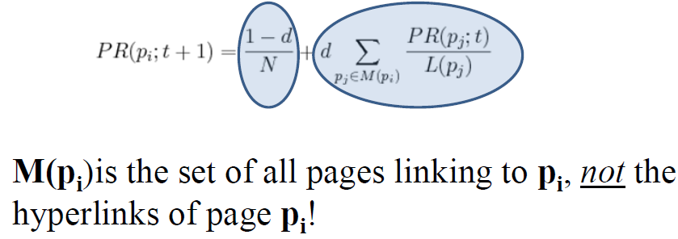

We are going to compute the Page Rank for a web page using map reduce. We are going to being with **(URL, list-of-URLs)** where list-of-URLs is the outlinks from the webpage. We are going to transform the above expression to **(URL, (PageRank, list-of-URLs))** where **PageRank is the initial guess, usually 0.5 or 0.1**.

The above expression will act as input to the **Map**, the map for each ***u*** in the **list-of-URLs** will output **(u, URL, PR(URL)/Length of list-of-URLs)** i.e., the output link, with the voter, the page rank of the voter divided by number of output urls from the web page, the large the page rank of the URL, the more support to the web page will be give and we are going to output the **(URL, list-of-URLs)**.

Each Web page’s hyperlinks (outlinks, or votes) are “pivoted”, and we now tally up each Web page’s inlinks (voters) instead. In the **Reducer**, the input will be (URL, list-of-URLs) and many URLs pairs and it going to calculate the **(URL, (new PR, list-of-URLs))**. We are going to aggregate the votes from each voter and then going to multiply the aggregated value with the dampening factor. We are also going to add the the probability of the direc typing the URL and reaching the web page. The sum of the above expression will be the page rank of the web page. We are going to iterate through this mapper and reducer part couple of times and will observe that page rank is converging, after a while page rank will be constant and that will be the final page rank of the web page.

**Code Explanation**

For implementing the PageRank Algorithm, we have the concept it three parts which are named as **Graph Builder, Iterator and Viewer**. We have the main class name **WikiSpecies**, which is going to call the Graph Builder, then count the number of total species from the output of the Graph Builder and then going to call the Species Iterator for the number of times the iteration is defined and the lastly Species Viewer, in which the final result is present of the page rank.

In **WikiSpecies**, we have parameterized the **Initial PageRank, Dampening factor, Number of Iterations, input directory path and output directory.** The main concept behind parameterizing the parameter is that it allows users to change them from the argument list without going within the code and changing them explicitly.

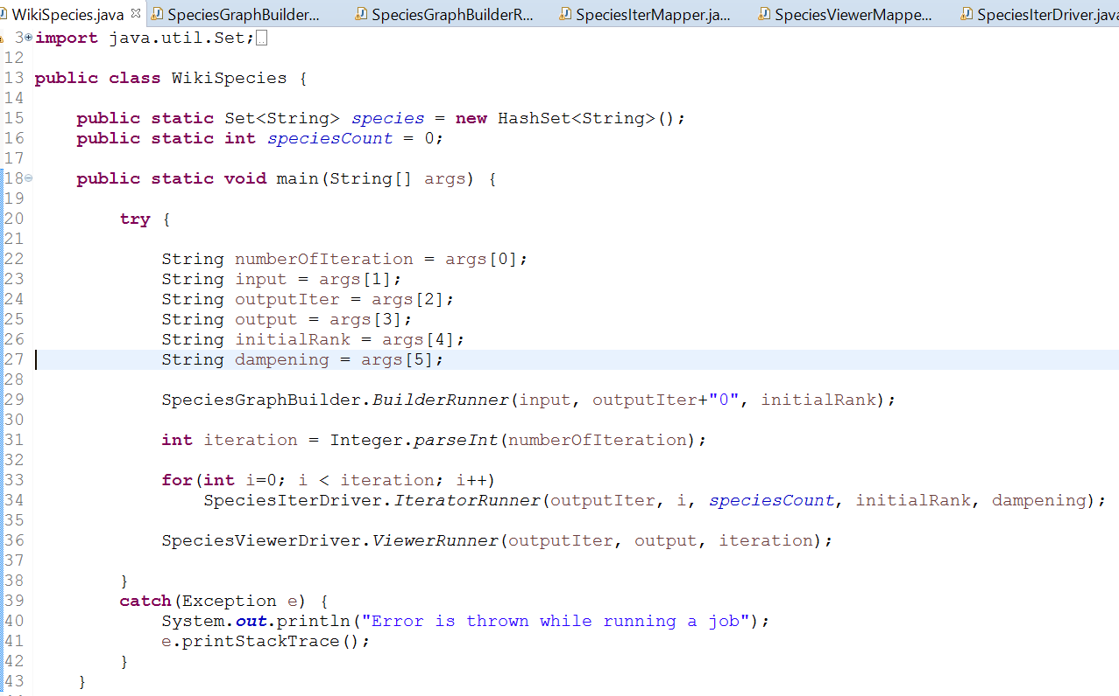

So as soon as, the WikiSpecies main class is run, it is going to call the GraphBuilder in which JobConf we are setting the initial page rank which can be later used in the GraphBuilder Reducer. Setting of the value can be seen below:

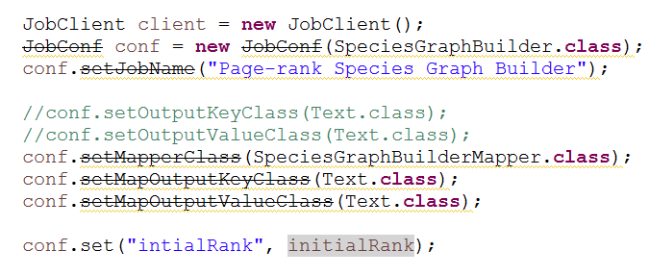

If you want to fetch the set value in either the mapper or reducer, we use the below code:

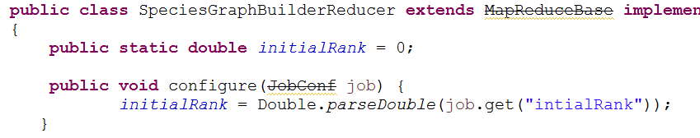

In **GraphBuilder Mapper**, we are going to iterate through each line of the shredded text file and **extract the URL** of the web page and **related outlinks of that URL**. In each line after every URL there is comma (,) and outlinks are written within **[[ ]]**. Below image is the function to get the title:

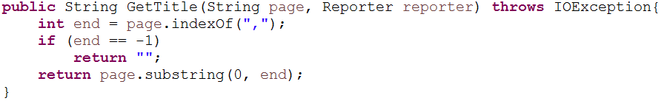

Below is the image to get the outlinks in the line. If in a particular outlink there is space, we are replacing it with **“_”**. Since we are using space and colon later for manipulation, it is good practice to remove them now, otherwise later they will be considered as different url instead of one. We are going to output the tile as key and outlinks separated by space as value of the mapper.

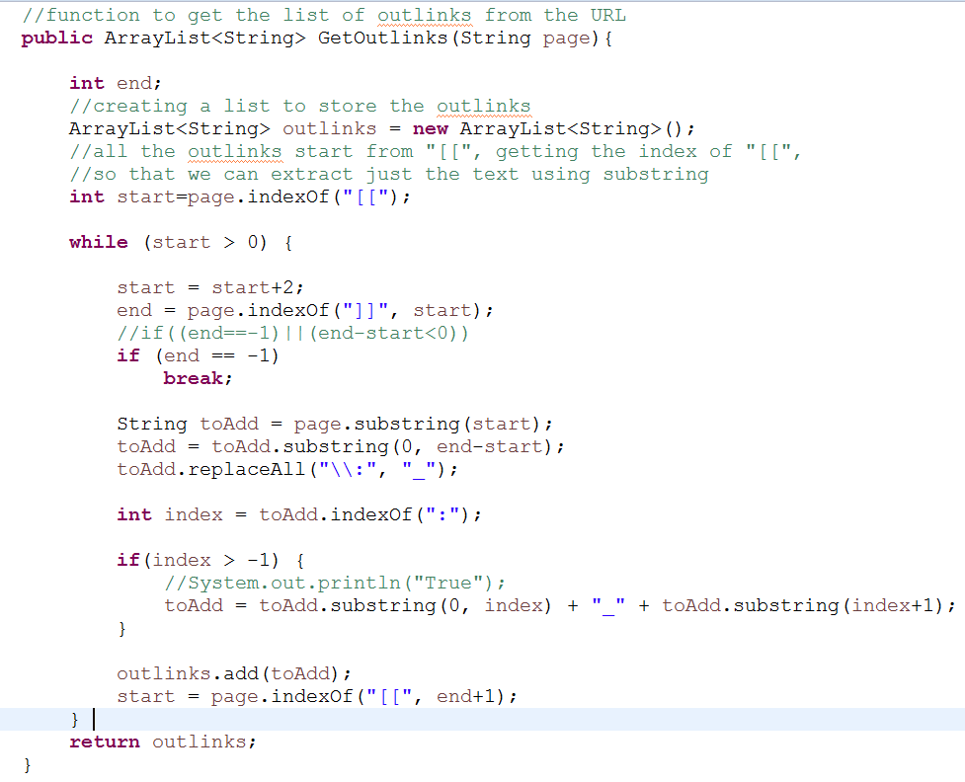

In the **GraphBuilder Reducer**, we are removing the space and colon from the outlinks and giving each URL a page rank as 0.1 (it is guessed one). The output of reducer will be **(URL, assumed page rank of the URL and the space separated outlinks)** and format will be **[URL PR: list-of-URLs]**. Assumed page rank is set by the user by passing the argument in the starting.

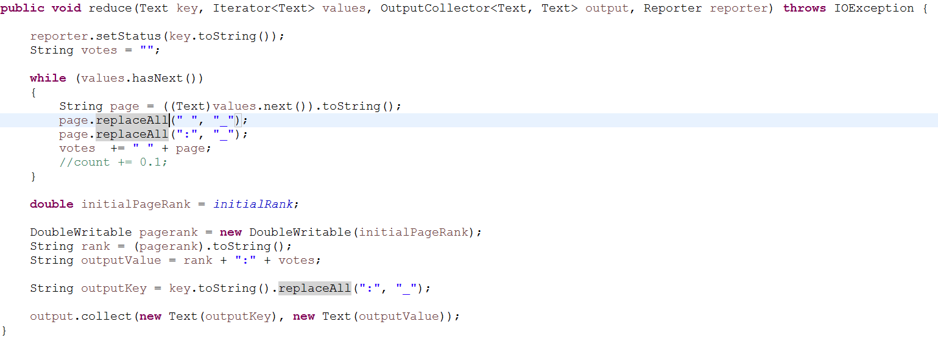

The output of the Graph Builder MapReduce will be considered as input for the species iterator MapReduce. But before that we are going to use the generated output file to count the total number of species present in the document, which we are going to use for computing Silver Surface formula. For computing total number of species, we are going to have a globally defined static HashSet, HasheSet because it does not store duplicate values, in which we are going to read the output file and store the names using StringTokenizer.

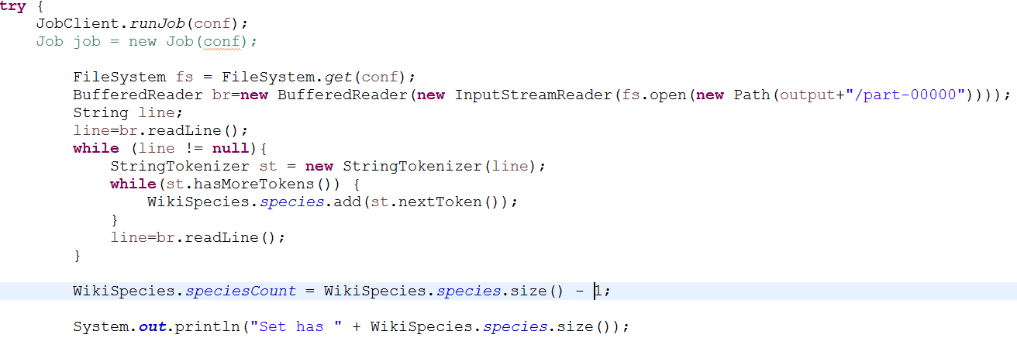

After computing the total number of species, we are going to subtract one from the size of HashSet as it will be storing 0.1: value as well, since we have used **“ “** as a token to split the line. We got total species as **1156**. The SpeciesIterator will receive the input as **URL, Page Rank and list-of-URLs** from the Graph Builder and **Total Species count, initial page rank and dampening factor** will be set in the jobconf of the Iterator Driver, which can be retrieved using Configuration method.

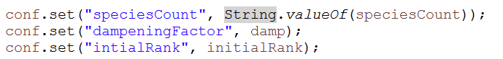

**Retrieval of the above values in Mapper**

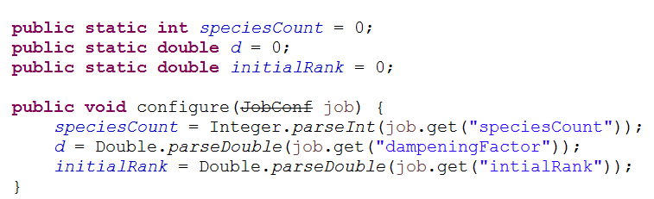

In the **SpeciesIterator Mapper,** we are going to split the input based on colon **“:”**, where the left part is the URL and page rank and the right part will be the list of the URL’s from that web page. If there is not **“:”**in the line, we are not going to considered that line. Now we are going to split the left part of the above part based on space or tab **Page Title and Page Rank.**

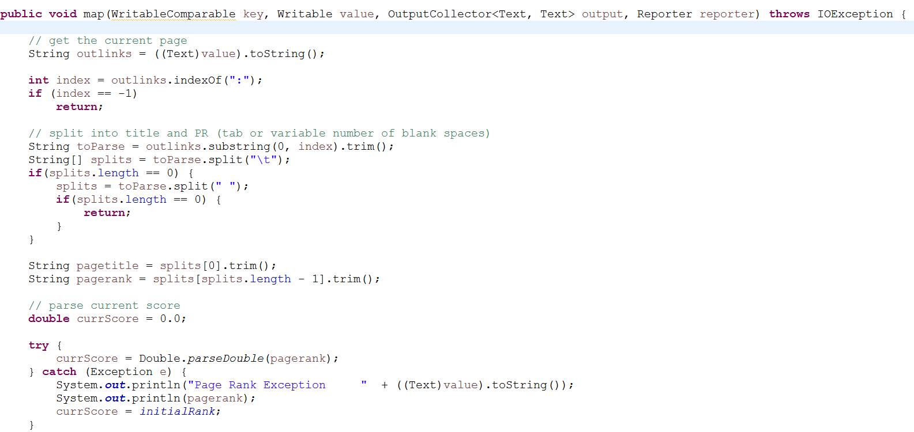

Now we are left with the string of the outlinks separated by **“ “,**  we are going to compute the number of the outlinks from the web page.

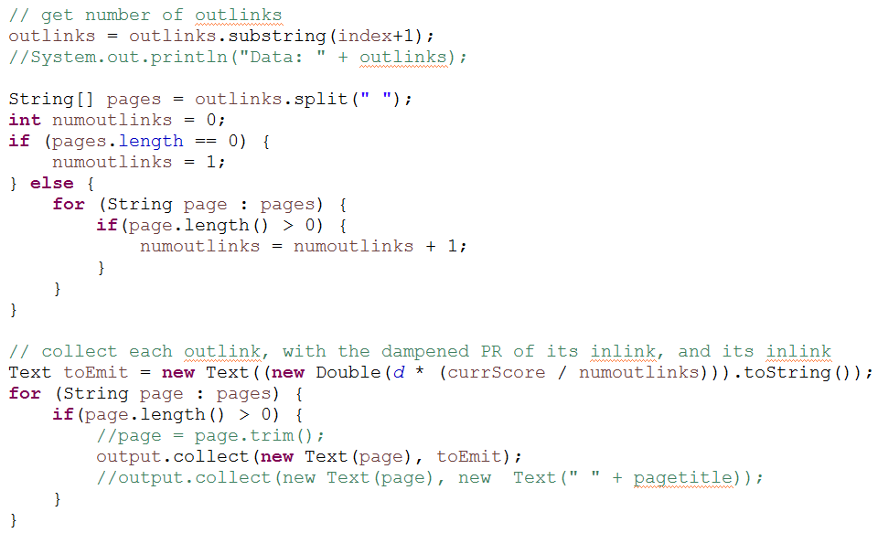

We are going to compute the **Silver surfer formula**, using the above values. We are going to assume the dampening factor and multiply it with the (Page Rank of the page / Length of the list-of-URLs) i.e., **[d * (PR * num_of_outlinks)]**.

The output of the mapper will be the URL and computed page rank, URL. We are also going to output the webpage page rank [(1 – d) / N], i.e., the probability of direct reaching the web page. These are the URLs which were input to the mapper and also output the list-of-URLs for these web pages.

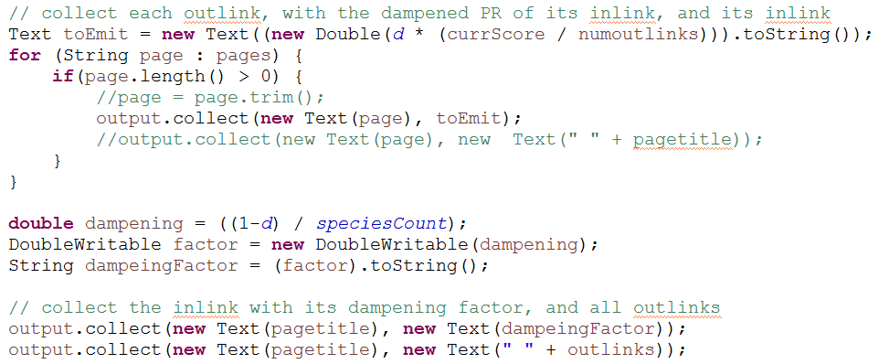

In the **SpeciesIterator Reducer**, we are splitting the data based on **“:”** and **“ “,**  to aggregate the score of the web page and separating the outlinks

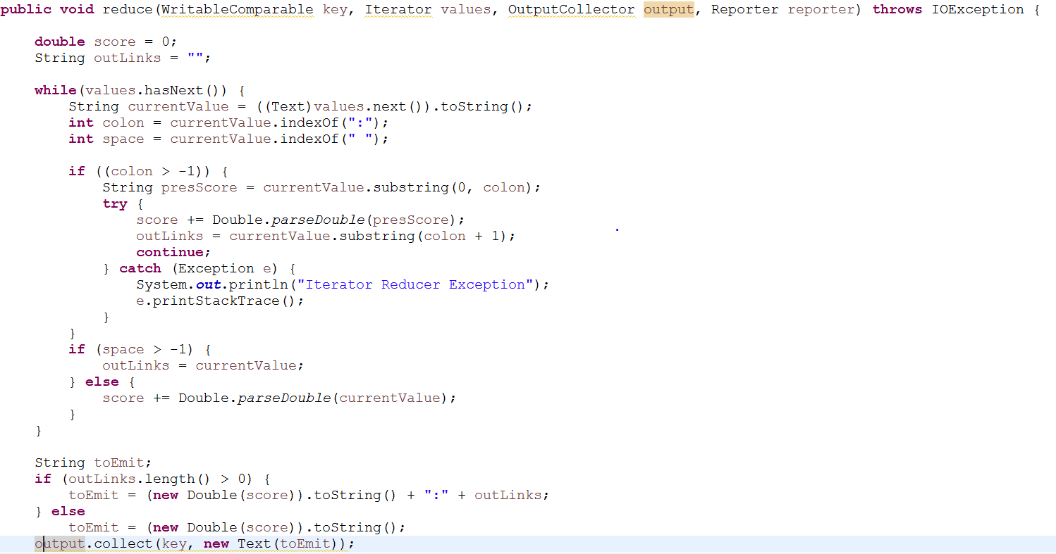

The output of the reducer will be the key as URL and value as the page rank of the URL and outlinks which are colon separated. For species iterator, we are having 5 reducer tasks. This Species Iterator will be executed couple of times, till the time page rank converges completely. The converged page rank is going to act as input for Species Viewer.

In the **SpeciesViewer Mapper**, we are going to take the input from the Species Iterator, we are going to make the page rank as key and page title i.e., URL as value. We are going to make page rank as negative, so that when mapper sort the value, we can have the highest rank at the top. The output of the species viewer we conclude the page rank algorithm.

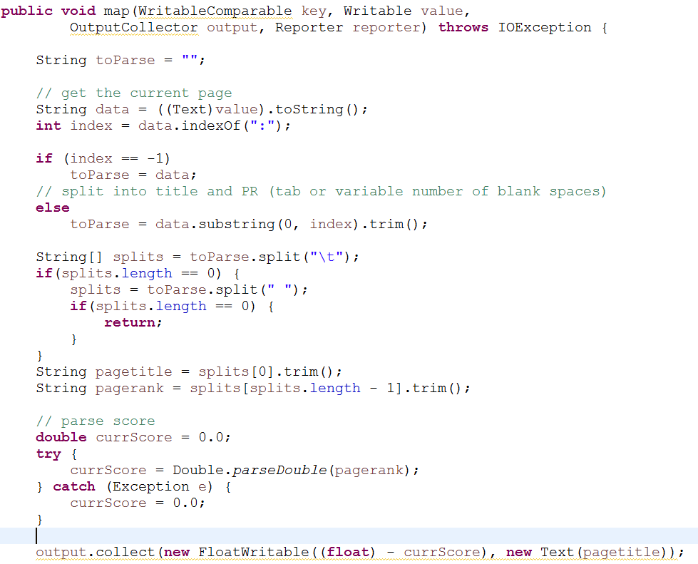

We have used if and else loop, to separate the page which have outlinks and the page which don’t have outlinks.

Since, the pages with outlinks will have colon within them and other pages won’t have colon in them.

**Cleaning Performed in the code**

* Removed the spaces and colon from the title, as earlier it was breaking URL like **Homo sapiens** into two and giving a page rank for both the URL considering them as different and it was also changing the page rank of other web pages as well. **I replace the “ “ and “:” with “_”.**

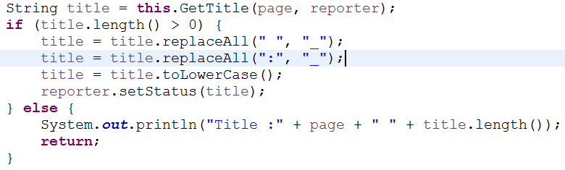

* Removed the spaces and colon from the list-of-URLs as, at many places we are splitting the data based on “ “ and “:”. So having the presence of these punctuation in the text result into the wrong computation and we were getting output as Key as Integer and value as Integer. There were presence of some different locale in the text which has “:” between the given URL, it was splitting them and they both were considered as outlink which is not the actual case, after replacing them those discrepancies were removed.

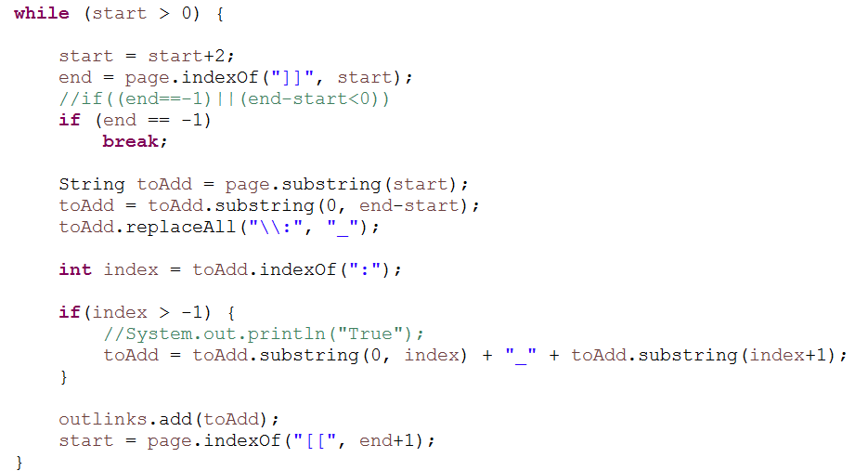

* While computing the page rank, the total number of species were not taken in account, I have computed the N and included while calculating the dampening factor as **(1-d) / N, where N is the total number of species in the document.**
* There was few lines where there are open brackets but that are not closing, we have to take care of those cases as well. What eventually is happening is, the present code is considering one long string which has 2 outlinks as one. The code below is taking care of that thing, instead of closing square bracket there is a “,”. I am using that to retrieve the URL

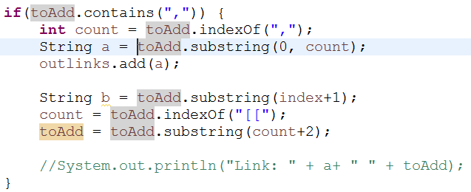

* In the **SpeciesIterator Mapper,** we were outpting the inlinks as well, which is not required. We commented that line

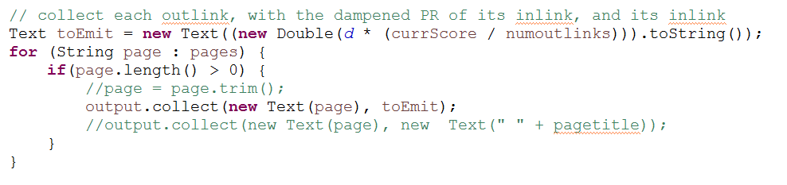

* In the **SpeciesViewer Mapper,** the code was to only read the data which has outlinks, I wrote if else loop to tackle the condition. Because the code was not there, the Mapper was not outputting the pages which didn’t have outlinks. Page with outlink will have colon and otherwise will have not have colon.

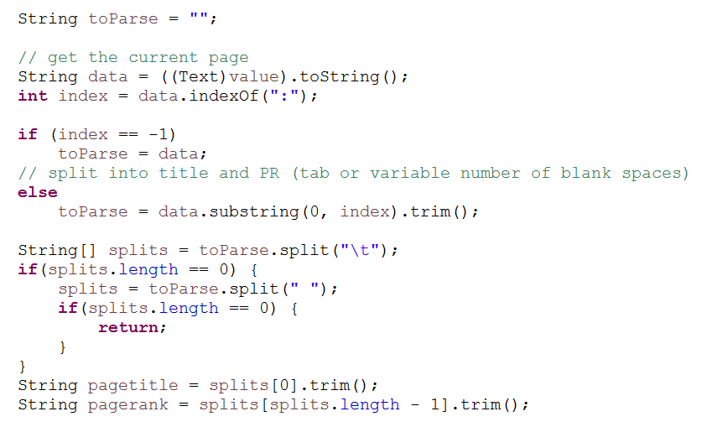

* **Dampening factor, Intial PageRank and Number of Iteration are parameterized in the code.** I have changed the d to 0.85 from 0.98 and Initial Page Rank from 1 to 0.1, as these are appropriate values.

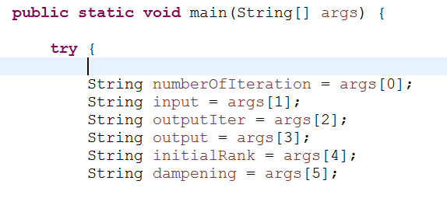

* **Reading file from the hdfs,**  I read the file from the hdfs to compute the total number of species which will be helpful in computing the Silver Surface formula.

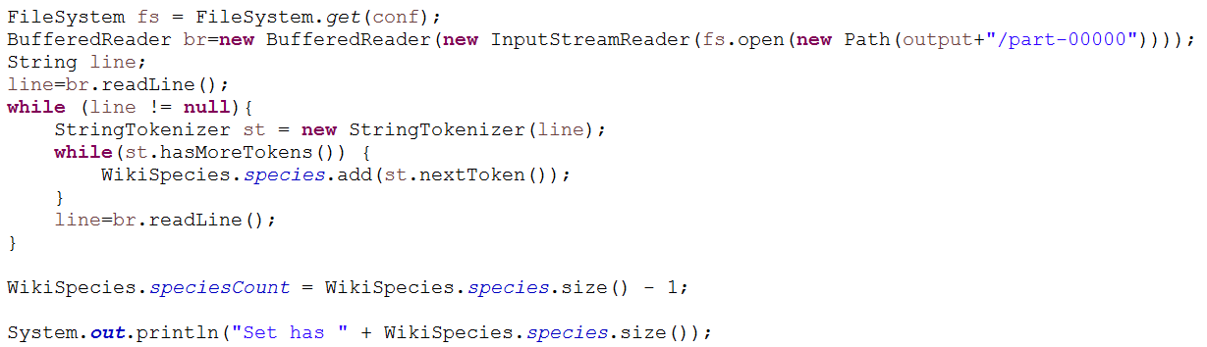

**Result**

The data is converging; this has been observed in the result. I have run Species Iterator for 27 times and observed the value of URL “**reptilia**”. For 10th iteration the value is 2.79, for 11th iteration the value is 3.0, for 18th iteration the value is 3.49, for 22nd iteration the value is 3.61 and for 26th Iteration the value is 3.68 and the value in the final viewer is 3.70. This implies that page rank is converging for URLs. The assumed initial rank is 0.1 and dampening factor is 0.85. The maximum page rank which we are getting is 20.45, although these ranks should be less than 1 as these are the probabilities but for that we need to know and consider the probabilities appropriately.

**Standalone Output**

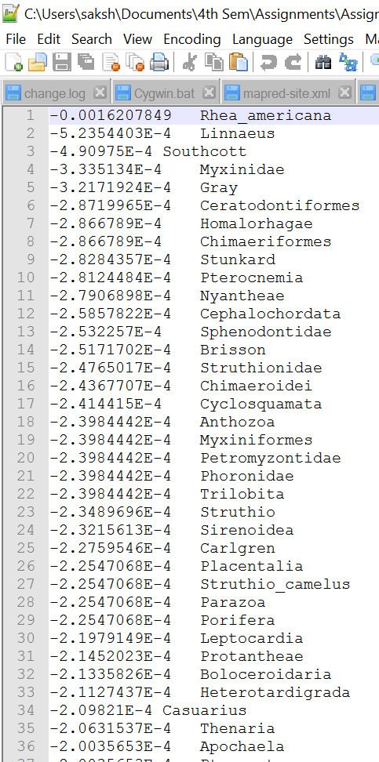

**Fully Distributed Mode Execution Snapshots**

Commands to create java class and jar file and execute the jar on the Hadoop pseudo mode

We are sitting in a directory two cd inside where hadoop-0.20 folder is present.

1. Making the directory to store the class files

***mkdir -p wikispecies_classes***

1. Compiling the java class to make class file of the java class

***javac -classpath ../../hadoop-0.20.2/hadoop-0.20.2-core.jar -d wikispecies_classes *.java***

1. Making a jar file with name wikispecies.jar

***jar cvf wikispecies.jar -C wikispecies_classes/ .***

1. Execution of the wikispecies.jar in the pseudo distributed mode. It take 4 arguments, the first as number of iterations, second as the input folder from where it is going to read the input txt file, third as intermediary folder to store the output of the iterations and fourth as the final output folder to store the result of Species Viewer

***../../hadoop-0.20.2/bin/hadoop jar wikispecies.jar com.species.Driver.WikiSpecies 27 inputPageRank outputItr output***

1. Putting the txt file on the hdfs. Because execution in the pseudo distributed mode, look for the file on the hdfs://localhost:9000/

***../../hadoop-0.20.2/bin/Hadoop fs -put "C:/cygwin64/home/saksh/HadoopWorkspace/PageRank/inputPageRank/species_medium.txt" inputPageRank***

1. To get the file from the hdfs server to local machine is

***../../hadoop-0.20.2/bin/hadoop fs -copyToLocal outputItr* "C:\cygwin64\home\saksh\Hadoop Workspace\PageRank\outputFile"***

